Your Ref: Our Ref: Date: 31st July, 2025
REF NO.:CHAG/A6/3

THE EXECUTIVE DIRECTOR
CHRISTIAN HEALTH ASSOCIATION OF GHANA
P. O. BOX AN7316
ACCRA

Dear Sir/ Madam,
SUPPLY OF VACCINE REFRIGERATOR
Please find enclosed the following document submitted on our offer for the Supply of Vaccine Refrigerator.

- Bid Form

- Price Schedule

- Company Certificates

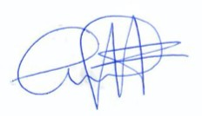
Yours faithfully,



………………………
Kwaku Ansong
Managing Director

